Grade Level | Class  Teacher | Description
PreK-2 | Beginner Conversational Hindi  Nandita Sinha | ICC’s youngest Hindi students learn common greetings and everyday nouns such as family members, colors, numbers, food, and animals. They participate in simple conversations through show-and-tell and activities like Simon Says. They are also introduced to the Indian Heritage through books and Indian iconography. Enrollment limited to 10.
PreK-1 | Introduction to Chess for PreK-K  Chess Club of Fairfield Country | Children as young as 4 learn the basic rules of chess and how to play and practice simple tactics and combinations requiring them to formulate simple plans. Common patterns and checkmates are covered. Children will have the opportunity to participate in a mock tournament on the last day of class. Enrollment limited to 8. | 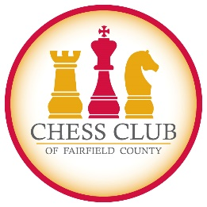
1-3 | Dances of India  Jayshree Srikanth and Chhavi Gupta,  DanceXStudio | Jayshree, Bollywood choreographer and Chhavi, Jayshree’s teaching assistant, teach a Bharatanatyam curriculum infused with Bollywood, Garba and other Indian dance. Dandia sticks, scarfs, pompoms, streamer wands, and glow gloves keep dance fun. At the end of the session, children will have the opportunity to perform on stage. Enrollment limited to 15. | Jayshree Srikanth
2+ | Warli Art  Prachi Khade- Gurjar | Warli Art is one of the oldest art forms in India. It uses geometrical shapes to create motifs of human beings, animals, and nature and weave a story about daily life in a loose rhythmic pattern. Kids learn about the lifestyle of an ancient Indian tribe as well as how to express living forms through shapes. They will create masterpieces such as greeting cards and sconces. Prachi has a Masters in Landscape Architecture and teaches Warli in Stamford. Enrollment limited to 12.
3-6 | Yoga and Mindfulness for Older Kids  Kathy Leon-Lacourt | Because of its ability to help children manage their energy and emotions, build self-confidence and develop greater compassion, an increasing number of schools are integrating Yoga and Mindfulness into the class day. Kathy, a Greenwich Country Day School Spanish teacher and Registered Yoga Teacher, instructs children how to relax their minds, enhance concentration, and improve flexibility, balance, and muscle tone. Enrollment limited to 14. For hygiene, children are encouraged to bring their own yoga mats.
PreK-K | Dances of India  Jayshree Srikanth and Chhavi Gupta,  DanceXStudio | Jayshree, Bollywood choreographer and Chhavi, Jayshree’s teaching assistant, teach a Bharatanatyam curriculum infused with Bollywood, Garba and other Indian dances. Dandia sticks, scarfs, pompoms, streamer wands, and glow gloves keep dance fun. At the end of the session, children will perform for family. Enrollment limited to 14. | Jayshree Srikanth
PreK-2 | Yoga and Mindfulness for PreK – 2  Claudia Foster | Yoga and mindfulness promote the development of healthy habits of mind that will support children in managing and regulating their energy and emotions as well as build self-confidence and compassion for others. Claudia, a Greenwich Country Day School Kindergarten teacher, offers a fun and engaging yoga and mindfulness program that introduces students to the physical, mental and social benefits of a yoga and mindfulness practice. Enrollment limited to 14. For hygiene, children are encouraged to bring their own yoga mats.
K-3 | Beginner Conversational Hindi  Nandita Sinha | This class is for children who have had at least one year of Hindi or who understand Hindi and are beginning to speak. Students will expand their vocabulary and will participate in simple conversations through show-and-tell and fun activities such as Simon Says. Children will also be introduced to the Indian Heritage through books and Indian iconography. Enrollment limited to 10.
1+ | Intermediate Chess  Chess Club of Fairfield County | For children and adults who know the rules of the game, and/or have a USCF chess rating of 200 - 500, the Chess Club of Fairfield County comes to ICC to work with kids and adults to improve their ratings and/or strategic grasp of the game. Students will have the opportunity to participate in a mock tournament on the last day of class. Enrollment limited to 12. Adults welcome.
1-3 | Intermediate Conversational Hindi  Vaishale Akole | This class is for children who have taken two years of Hindi and/or are competent in basic Hindi. Children engage in small conversations and role playing, build vocabulary (visit India, order food, sports, vacation, school, family friends), participate in skits and storytelling, practice with teacher guidance and build confidence. At the end of the course, students should be able to converse on a given topic. Enrollment limited to 10.
2-3 | Ultimate STEM Amanda Sackey | An all-new STEM curriculum for the Winter/Spring Session, developed and taught by a popular Rye Country Day Science teacher, challenges kids to solve engineering and experimental problems and encourages them to take risks and innovate. The explore, design, evaluate, and redesign process helps them understand the complexity of precision measurement and experiment with the forces of the physical, chemical, and biological sciences. Some lessons will focus on the development of math skills. Others will use acquired skills for design and engineering. Enrollment limited to 15. | 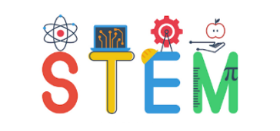
3-4 | Coding Level 2: Scratch  Purab Angreji and Ben Grass | For kids who have taken Scratch Jr., who took Scratch in the Fall session, or have had prior exposure to coding, Winter/Spring Scratch will build their programming and coding knowledge. Scratch’s piece-by-piece solving mechanisms, that simulate how a written code works, allow students to put together different blocks -- that act as lines of code -- to produce a project. Kids can design new animations or games or add complexity to projects started in the fall. Enrollment limited to 12. | 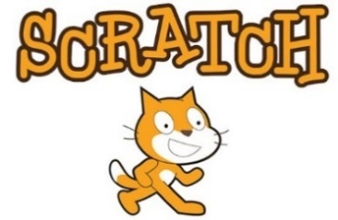
4-8 | First Lego League  Jaimin Vyas | This class is one-hour. MissonBots, ICC’s First Lego League team, takes a deep dive into programming with LEGO® MINDSTORMS® EV3 brick – from basic blocks for simple navigation to advanced programming using sensors. A new programming concept will be introduced each week and applied to code mission(s) defined for 2017–2018 FLL HYDRODYNAMICS challenge.  Required: Serious commitment to coding and programming and personal laptop installed with MINDSTORMS® software. Parents are encouraged to purchase LEGO® MINDSTORMS® EV3 Core Set for weekday practice. Enrollment limited to 12. | 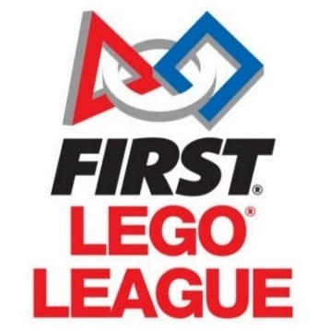
PreK-K | Introduction to Chess for PreK-K  Chess Club of Fairfield Country | Children as young as 4 learn the basic rules of chess and how to play and practice simple tactics and combinations requiring them to formulate simple plans. Common patterns and checkmates are covered. Children will have the opportunity to participate in a mock tournament on the last day of class. Enrollment limited to 8.
K-1 | Ultimate STEM  Amanda Sackey | An all-new STEM curriculum for K-1, written and taught by our popular Rye Country Day Science teacher, challenges kids to solve engineering and experimental problems and encourages them to take risks and innovate. The explore, design, evaluate, and redesign process helps them understand the complexity of precision measurement and experiment with the forces of the physical, chemical, and biological sciences. Some lessons will focus on the development of math skills. Others will use acquired skills for design and engineering. Enrollment limited to 15.
K-3 | Beginner Conversational Hindi  Vaishale Akole | Children new to Hindi or who understand Hindi will learn greetings and everyday nouns including family members, colors, numbers, food, and animals. They will participate in simple conversations through show-and-tell and activities such as Simon Says. Enrollment limited to 10.
1-3 | Coding Level 1: Scratch Jr.  Purab Angreji and Ben Grass | Kids learn how to program interactive stories and games in this class taught by popular student teachers. In the process, they learn to solve problems, design projects, and creatively express themselves digitally. Purab and Ben will group kids who took Scratch Jr. in the Fall and first-time coding students. Scratch Jr. apps are free. Enrollment limited to 12. | 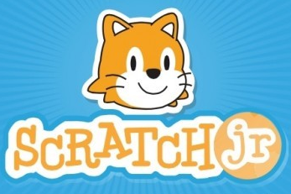
2+ | Advanced Conversational Hindi  Nandita Sinha | Class is taught in Hindi. Students engage in conversations, make mistakes, practice with guidance, build confidence, and, learn to speak without inhibition. Children will converse on school, family, friends, activities and other everyday topics and participate in skits and storytelling. Children should be in the second grade or have taken two years of Hindi. Enrollment limited to 10.
4-6 | Cricket  Rushil Jha | In addition to being a serious competitive sport, cricket, Indian’s most popular sport, is a fun game that can be played by as few as two players. Boys and girls will learn how to play, cricket terminology, rules, and code of conduct with a passionate student cricket teacher from Wilton High School. Soft tennis balls will be used. Enrollment limited to 10.

